Hotfix built for:

Platform x86

Milestone Integration v2.5

Milestone SDK 2016_R3_10.2.2538.1

Lenel OnGuard 7.3.345

This fix addresses an error in the alarm id passed from XProtect to Lenel on an acknowledgement. The invalid id would ultimately show up upon generating an alarm acknowledgement report.

Steps to reproduce, assuming the above versions are installed and running normally.

* Create an alarm definition within XProtect that maps to a reader alarm in the integration, for example, a triggering event of “Door Forced Alarm” based on the event "Access Control Event Categories", "OnGuard System".
* Trigger the alarm through Lenel. The alarm should be displayed in the XProtect monitoring station.
* Right-click the alarm in XProtect and acknowledge it. The alarm should become acknowledged on the Lenel system.
* Generate a alarm acknowledgement report through the “Alarm Acknowledgement Report” tab in “Views->Reports…”

Error case, prior to hotfix:

The alarm will be displayed with the incorrect description, “Granted Facility Code, No Entry”.

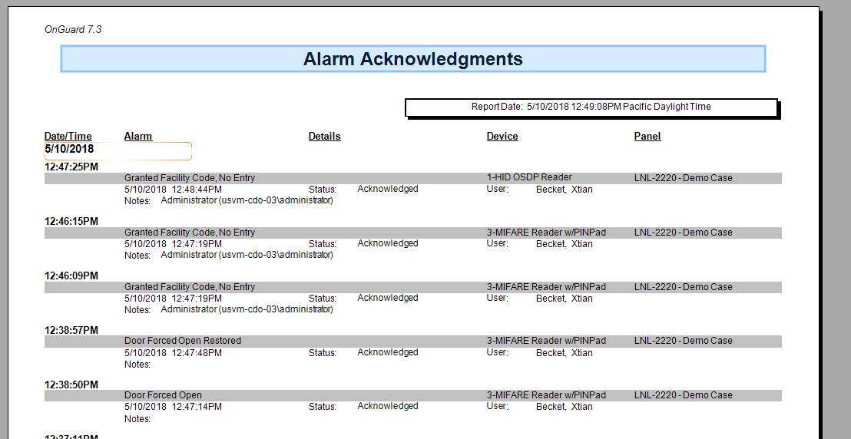

Corrected case, after the hotfix:

The alarm will display the correct type, such as “Door Forced Open”.

